Question 1Skipped
You are asked to debug a databricks job that is taking too long to run on Sunday’s, what are the steps you are going to take to identify the step that is taking longer to run?
A notebook activity of job run is only visible when using all-purpose cluster.
Correct answer
Under Workflow UI and jobs select job you want to monitor and select the run, notebook activity can be viewed.
Enable debug mode in the Jobs to see the output activity of a job, output should be available to view.
Once a job is launched, you cannot access the job’s notebook activity.
Use the compute’s spark UI to monitor the job activity.
Overall explanation
The answer is, Under Workflow UI and jobs select job you want to monitor and select the run, notebook activity can be viewed.

You have the ability to view current active runs or completed runs, once you click the run you can see the

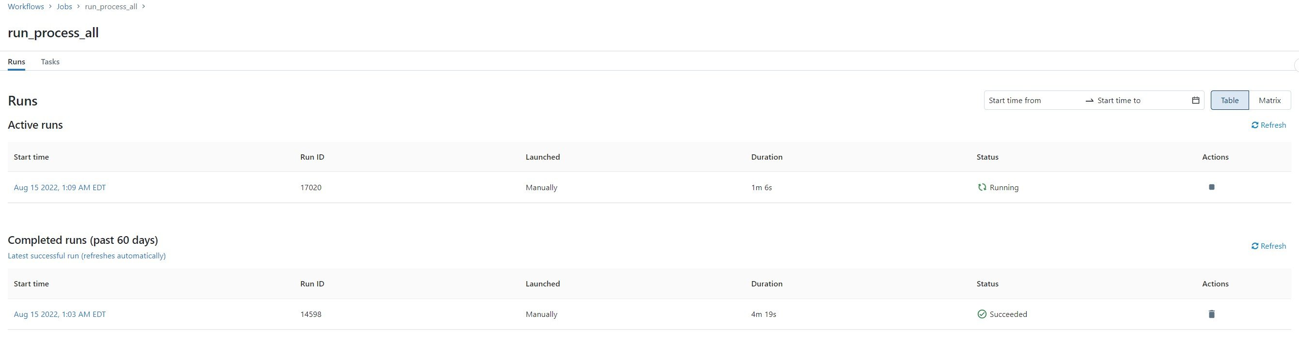
Click on the run to view the notebook output

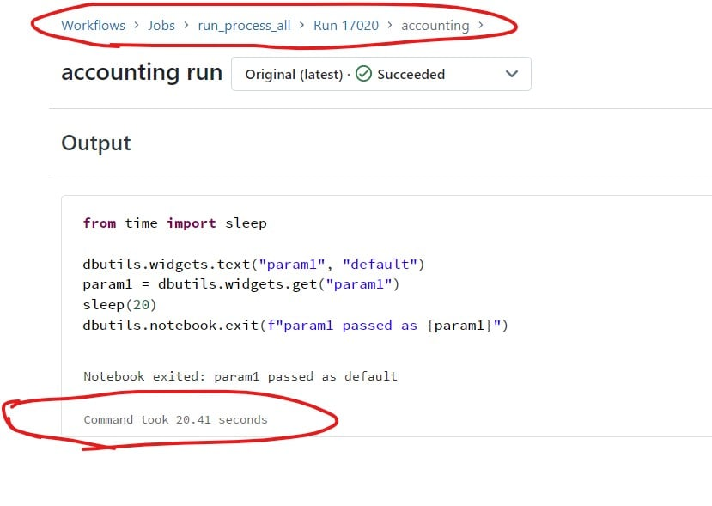

Domain
Production Pipelines
Question 2Skipped
Which of the following python statements can be used to replace the schema name and table name in the query?
- table_name = "sales"
- schema_name = "bronze"
- query = f"select * from schema_name.table_name"
- table_name = "sales"
- query = "select * from {schema_name}.{table_name}"
Correct answer
- table_name = "sales"
- query = f"select * from {schema_name}.{table_name}"
- table_name = "sales"
- query = f"select * from + schema_name +"."+table_name"
Overall explanation
The answer is

- table_name = "sales"
- query = f"select * from {schema_name}.{table_name}"

It is always best to use f strings to replace python variables, rather than using string concatenation.

Domain
ELT with Spark SQL and Python
Question 3Skipped
you are currently working on creating a spark stream process to read and write in for a one-time micro batch, and also rewrite the existing target table, fill in the blanks to complete the below command sucesfully.

- spark.table("source_table")
- .writeStream
- .option("____", “dbfs:/location/silver")
- .outputMode("____")
- .trigger(Once=____)
- .table("target_table")

Correct answer
checkpointlocation, complete, True
targetlocation, overwrite, True
checkpointlocation, True, overwrite
checkpointlocation, True, complete
checkpointlocation, overwrite, True
Domain
Incremental Data Processing
Question 4Skipped
You were asked to write python code to stop all running streams, which of the following command can be used to get a list of all active streams currently running so we can stop them, fill in the blank.

- for s in _______________:
- s.stop()

Spark.getActiveStreams()
Correct answer
spark.streams.active
activeStreams()
getActiveStreams()
spark.streams.getActive
Domain
Incremental Data Processing
Question 5Skipped
At the end of the inventory process a file gets uploaded to the cloud object storage, you are asked to build a process to ingest data which of the following method can be used to ingest the data incrementally, schema of the file is expected to change overtime ingestion process should be able to handle these changes automatically. Below is the auto loader to command to load the data, fill in the blanks for successful execution of below code.

- spark.readStream
- .format("cloudfiles")
- .option("_______",”csv)
- .option("_______", ‘dbfs:/location/checkpoint/’)
- .load(data_source)
- .writeStream
- .option("_______",’ dbfs:/location/checkpoint/’)
- .option("_______", "true")
- .table(table_name))
format, checkpointlocation, schemalocation, overwrite
cloudfiles.format, checkpointlocation, cloudfiles.schemalocation, overwrite
Correct answer
cloudfiles.format, cloudfiles.schemalocation, checkpointlocation, mergeSchema
cloudfiles.format, cloudfiles.schemalocation, checkpointlocation, append
cloudfiles.format, cloudfiles.schemalocation, checkpointlocation, overwrite
Domain
Incremental Data Processing
Question 6Skipped
Which of the following scenarios is the best fit for AUTO LOADER?
Correct answer
Efficiently process new data incrementally from cloud object storage
Efficiently move data incrementally from one delta table to another delta table
Incrementally process new data from streaming data sources like Kafka into delta lake
Incrementally process new data from relational databases like MySQL
Efficiently copy data from one data lake location to another data lake location
Overall explanation
The answer is, Efficiently process new data incrementally from cloud object storage, AUTO LOADER only supports ingesting files stored in a cloud object storage. Auto Loader cannot process streaming data sources like Kafka or Delta streams, use Structured streaming for these data sources.

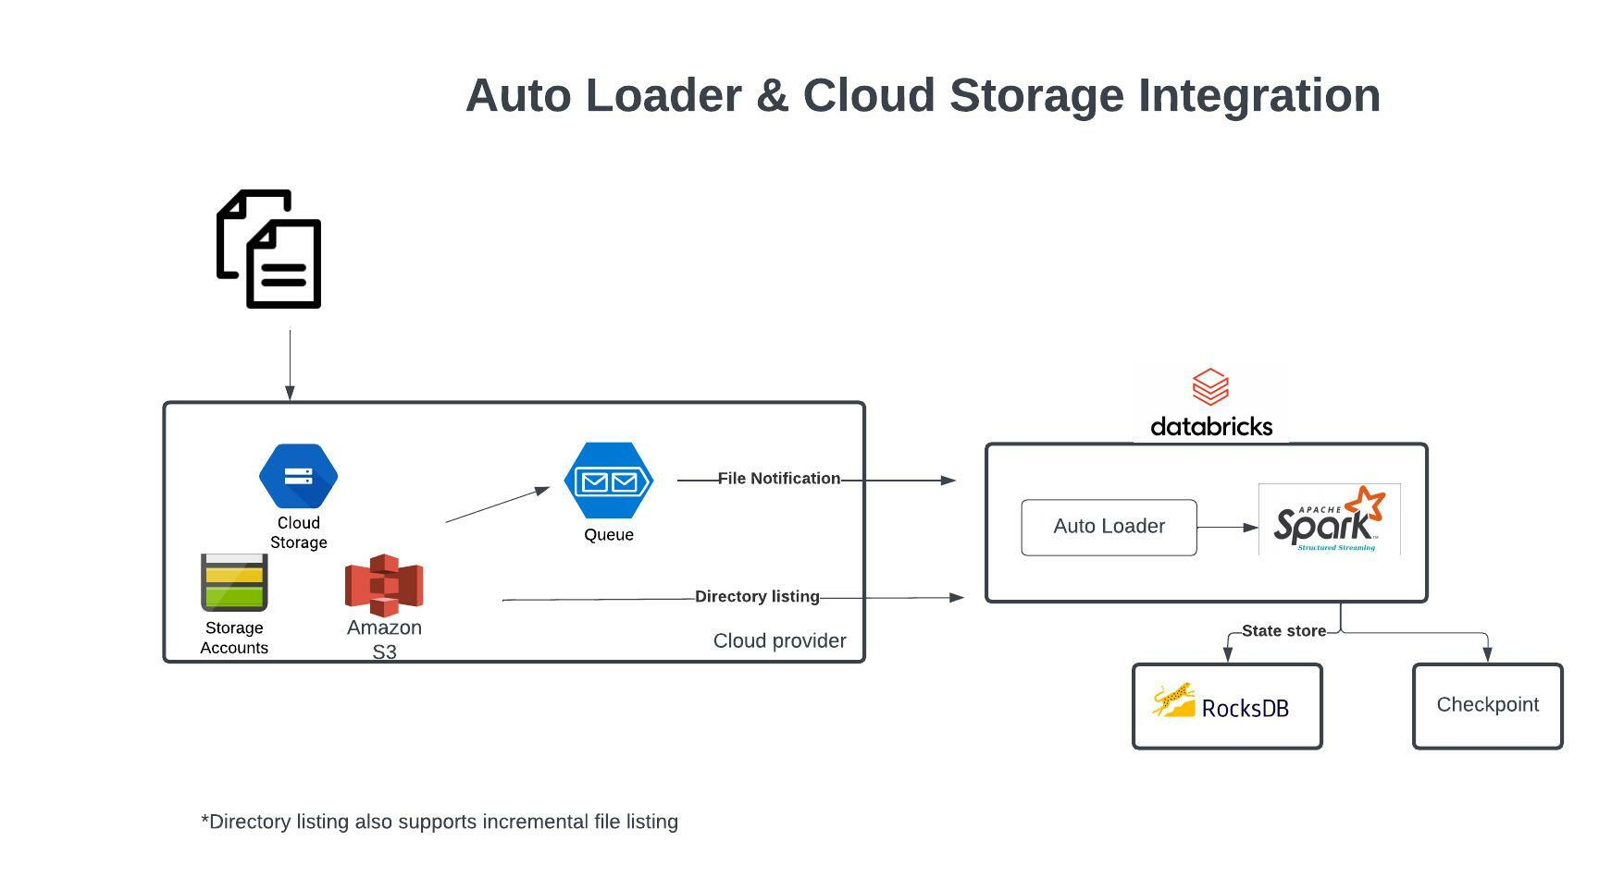
Auto Loader and Cloud Storage Integration

Auto Loader supports a couple of ways to ingest data incrementally

- Directory listing - List Directory and maintain the state in RocksDB, supports incremental file listing
- File notification - Uses a trigger+queue to store the file notification which can be later used to retrieve the file, unlike Directory listing File notification can scale up to millions of files per day.

[OPTIONAL]
Auto Loader vs COPY INTO?

Auto Loader
Auto Loader incrementally and efficiently processes new data files as they arrive in cloud storage without any additional setup. Auto Loader provides a new Structured Streaming source called cloudFiles. Given an input directory path on the cloud file storage, the cloudFiles source automatically processes new files as they arrive, with the option of also processing existing files in that directory.
When to use Auto Loader instead of the COPY INTO?

- You want to load data from a file location that contains files in the order of millions or higher. Auto Loader can discover files more efficiently than the COPY INTO SQL command and can split file processing into multiple batches.
- You do not plan to load subsets of previously uploaded files. With Auto Loader, it can be more difficult to reprocess subsets of files. However, you can use the COPY INTO SQL command to reload subsets of files while an Auto Loader stream is simultaneously running.

Domain
Incremental Data Processing
Question 7Skipped
You are asked to setup an AUTO LOADER to process the incoming data, this data arrives in JSON format and get dropped into cloud object storage and you are required to process the data as soon as it arrives in cloud storage, which of the following statements is correct
AUTO LOADER is native to DELTA lake it cannot support external cloud object storage
AUTO LOADER has to be triggered from an external process when the file arrives in the cloud storage
AUTO LOADER needs to be converted to a Structured stream process
AUTO LOADER can only process continuous data when stored in DELTA lake
Correct answer
AUTO LOADER can support file notification method so it can process data as it arrives
Overall explanation
Auto Loader supports two modes when ingesting new files from cloud object storage

Directory listing: Auto Loader identifies new files by listing the input directory, and uses a directory polling approach.
File notification: Auto Loader can automatically set up a notification service and queue service that subscribe to file events from the input directory.



File notification is more efficient and can be used to process the data in real-time as data arrives in cloud object storage.

Choosing between file notification and directory listing modes | Databricks on AWS
Domain
Incremental Data Processing
Question 8Skipped
What is the main difference between the bronze layer and silver layer in a medallion architecture?
Duplicates are removed in bronze, schema is applied in silver
Silver may contain aggregated data
Correct answer
Bronze is raw copy of ingested data, silver contains data with production schema and optimized for ELT/ETL throughput
Bad data is filtered in Bronze, silver is a copy of bronze data
Overall explanation

Medallion Architecture – Databricks

Exam focus: Please review the below image and understand the role of each layer(bronze, silver, gold) in medallion architecture, you will see varying questions targeting each layer and its purpose.

Sorry I had to add the watermark some people in Udemy are copying my content.
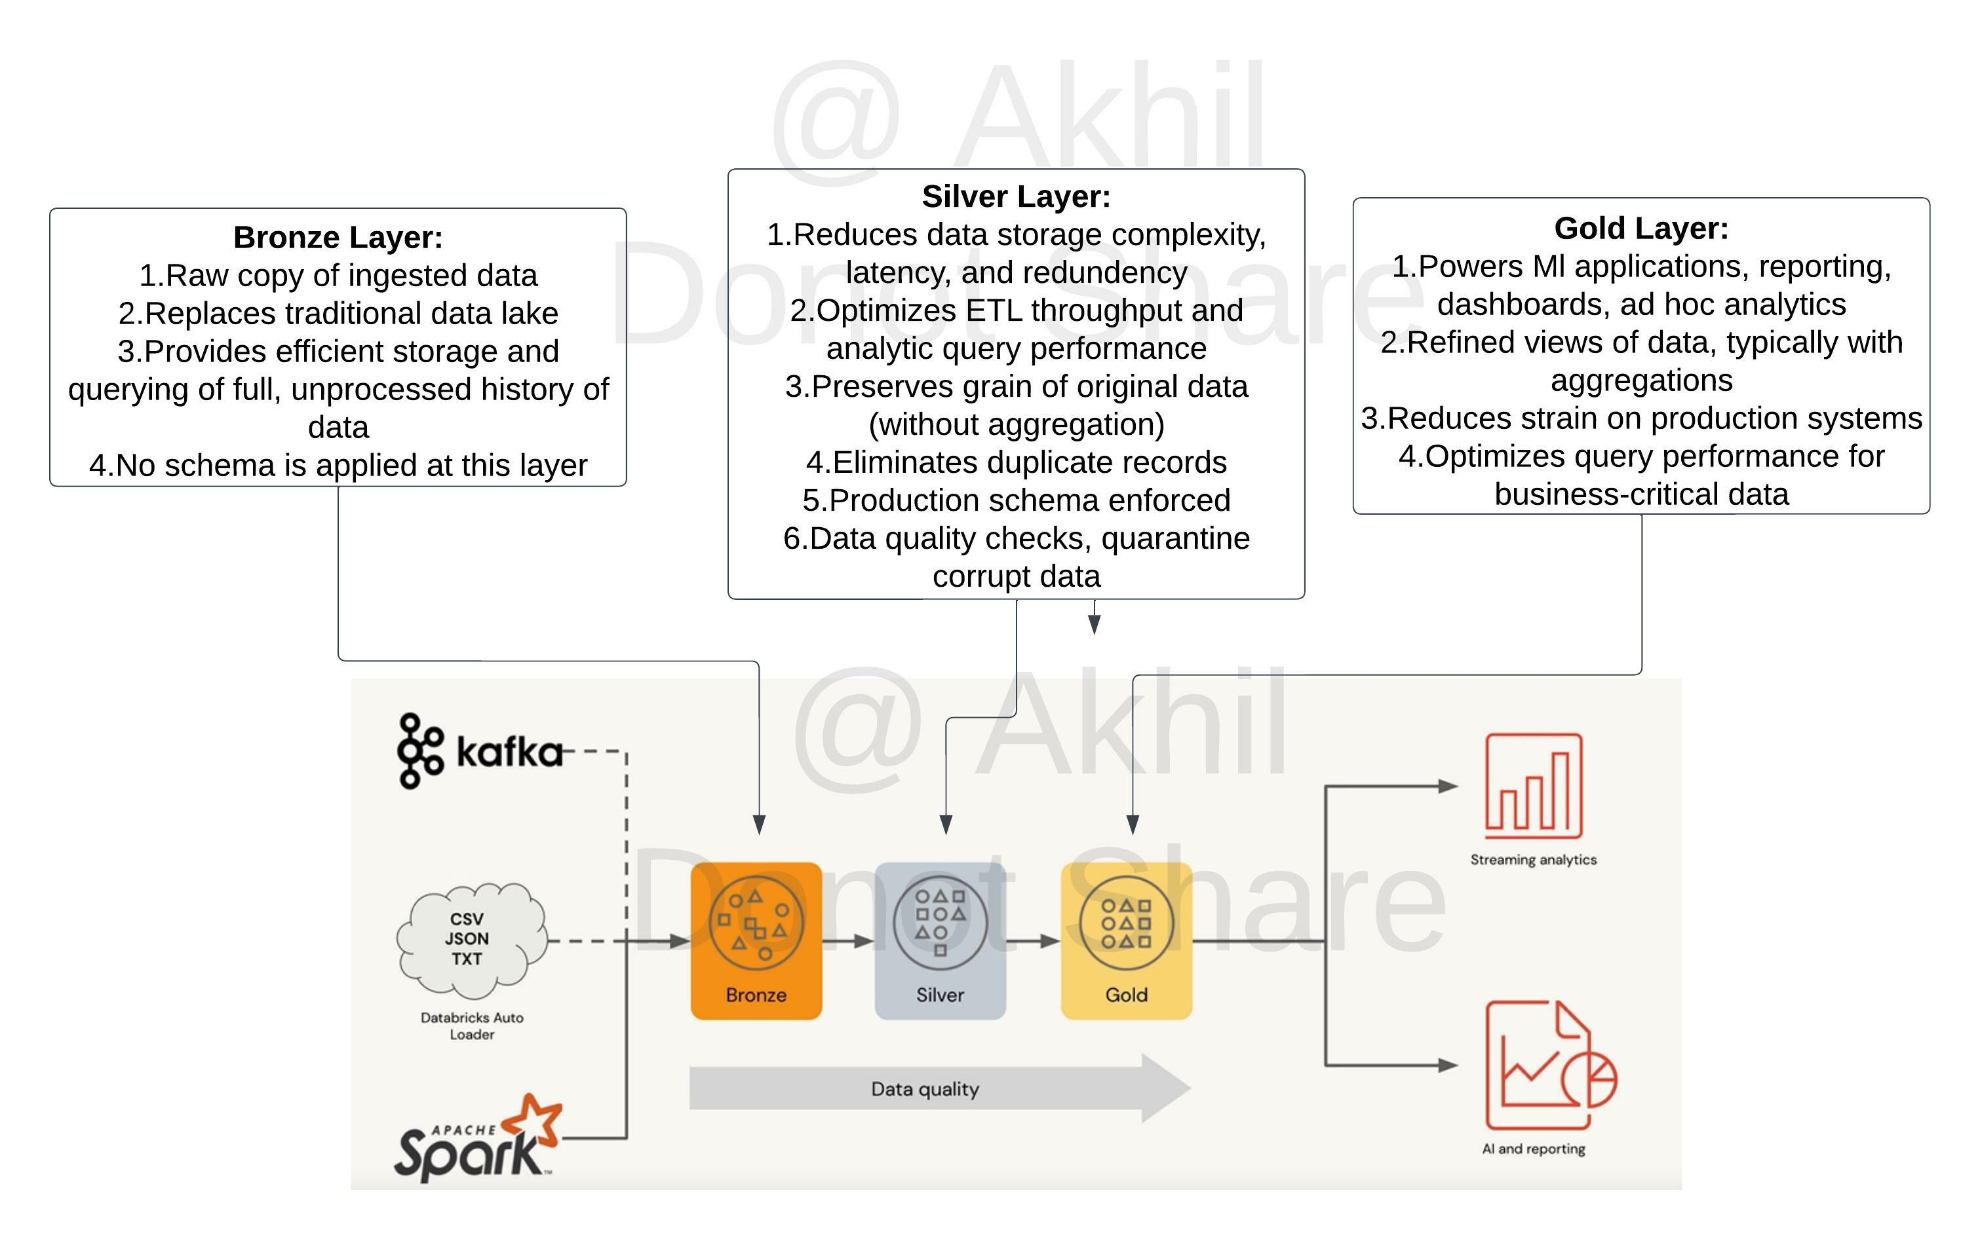

Domain
Incremental Data Processing
Question 9Skipped
What is the main difference between the silver layer and the gold layer in medalion architecture?
Silver may contain aggregated data
Correct answer
Gold may contain aggregated data
Data quality checks are applied in gold
Silver is a copy of bronze data
God is a copy of silver data
Overall explanation
Medallion Architecture – Databricks

Exam focus: Please review the below image and understand the role of each layer(bronze, silver, gold) in medallion architecture, you will see varying questions targeting each layer and its purpose.

Sorry I had to add the watermark some people in Udemy are copying my content.


Domain
Incremental Data Processing
Question 10Skipped
What is the main difference between the silver layer and gold layer in medallion architecture?
Correct answer
Silver optimized to perform ETL, Gold is optimized query performance
Gold is optimized go perform ETL, Silver is optimized for query performance
Silver is copy of Bronze, Gold is a copy of Silver
Silver is stored in Delta Lake, Gold is stored in memory
Silver may contain aggregated data, gold may preserve the granularity of original data
Overall explanation
Medallion Architecture – Databricks
Gold Layer:
1. Powers Ml applications, reporting, dashboards, ad hoc analytics
2. Refined views of data, typically with aggregations
3. Reduces strain on production systems
4. Optimizes query performance for business-critical data

Exam focus: Please review the below image and understand the role of each layer(bronze, silver, gold) in medallion architecture, you will see varying questions targeting each layer and its purpose.

Sorry I had to add the watermark some people in Udemy are copying my content.

Domain
Incremental Data Processing
Question 11Skipped
A dataset has been defined using Delta Live Tables and includes an expectations clause: CONSTRAINT valid_timestamp EXPECT (timestamp > '2020-01-01')
What is the expected behavior when a batch of data containing data that violates these constraints is processed?
Correct answer
Records that violate the expectation are added to the target dataset and recorded as invalid in the event log.
Records that violate the expectation are dropped from the target dataset and recorded as invalid in the event log.
Records that violate the expectation cause the job to fail.
Records that violate the expectation are added to the target dataset and flagged as invalid in a field added to the target dataset.
Records that violate the expectation are dropped from the target dataset and loaded into a quarantine table.
Overall explanation
The answer is, Records that violate the expectation are added to the target dataset and recorded as invalid in the event log.

Delta live tables support three types of expectations to fix bad data in DLT pipelines

Review below example code to examine these expectations,

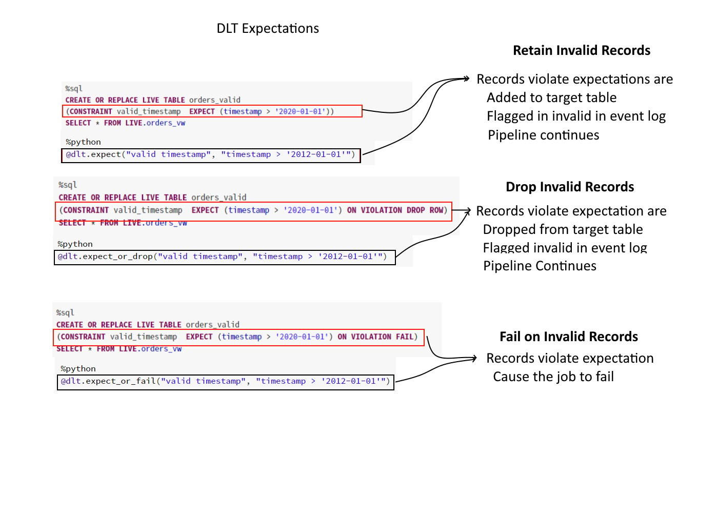

Domain
Incremental Data Processing
Question 12Skipped
A dataset has been defined using Delta Live Tables and includes an expectations clause: CONSTRAINT valid_timestamp EXPECT (timestamp > '2020-01-01') ON VIOLATION DROP ROW
What is the expected behavior when a batch of data containing data that violates these constraints is processed?
Records that violate the expectation are added to the target dataset and recorded as invalid in the event log.
Correct answer
Records that violate the expectation are dropped from the target dataset and recorded as invalid in the event log.
Records that violate the expectation cause the job to fail.
Records that violate the expectation are added to the target dataset and flagged as invalid in a field added to the target dataset.
Records that violate the expectation are dropped from the target dataset and loaded into a quarantine table.
Overall explanation
The answer is Records that violate the expectation are dropped from the target dataset and recorded as invalid in the event log.

Delta live tables support three types of expectations to fix bad data in DLT pipelines

Review below example code to examine these expectations,


Domain
Incremental Data Processing
Question 13Skipped
What is the output of below function when executed with input parameters 1, 3 :
- def check_input(x,y):
- if x < y:
- x= x+1
- if x>y:
- x= x+1
- if x <y:
- x = x+1
- return x

1
Correct answer
2
3
4
5
Overall explanation
The answer is 2
Domain
ELT with Spark SQL and Python
Question 14Skipped
Your colleague was walking you through how a job was setup, but you noticed a warning message that said, “Jobs running on all-purpose cluster are considered all purpose compute", the colleague was not sure why he was getting the warning message, how do you best explain this warning message?
All-purpose clusters cannot be used for Job clusters, due to performance issues.
All-purpose clusters take longer to start the cluster vs a job cluster
All-purpose clusters are less expensive than the job clusters
Correct answer
All-purpose clusters are more expensive than the job clusters
All-purpose cluster provide interactive messages that can not be viewed in a job
Overall explanation
Warning message:
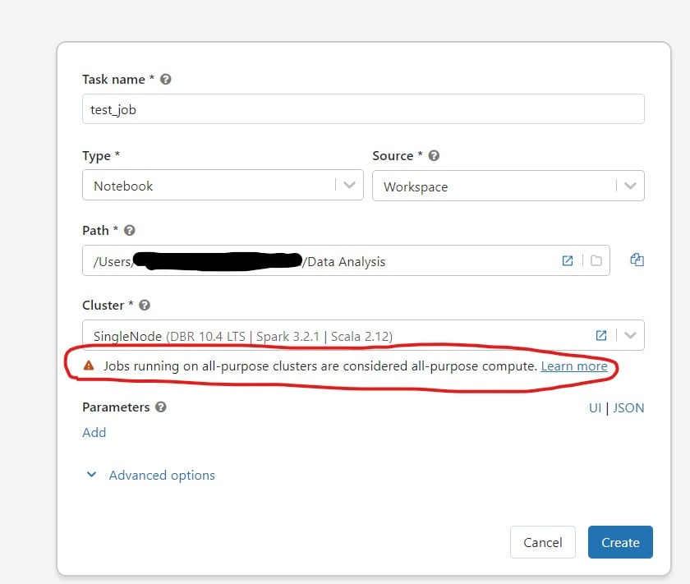

Pricing for All-purpose clusters are more expensive than the job clusters

AWS pricing(Aug 15th 2022)
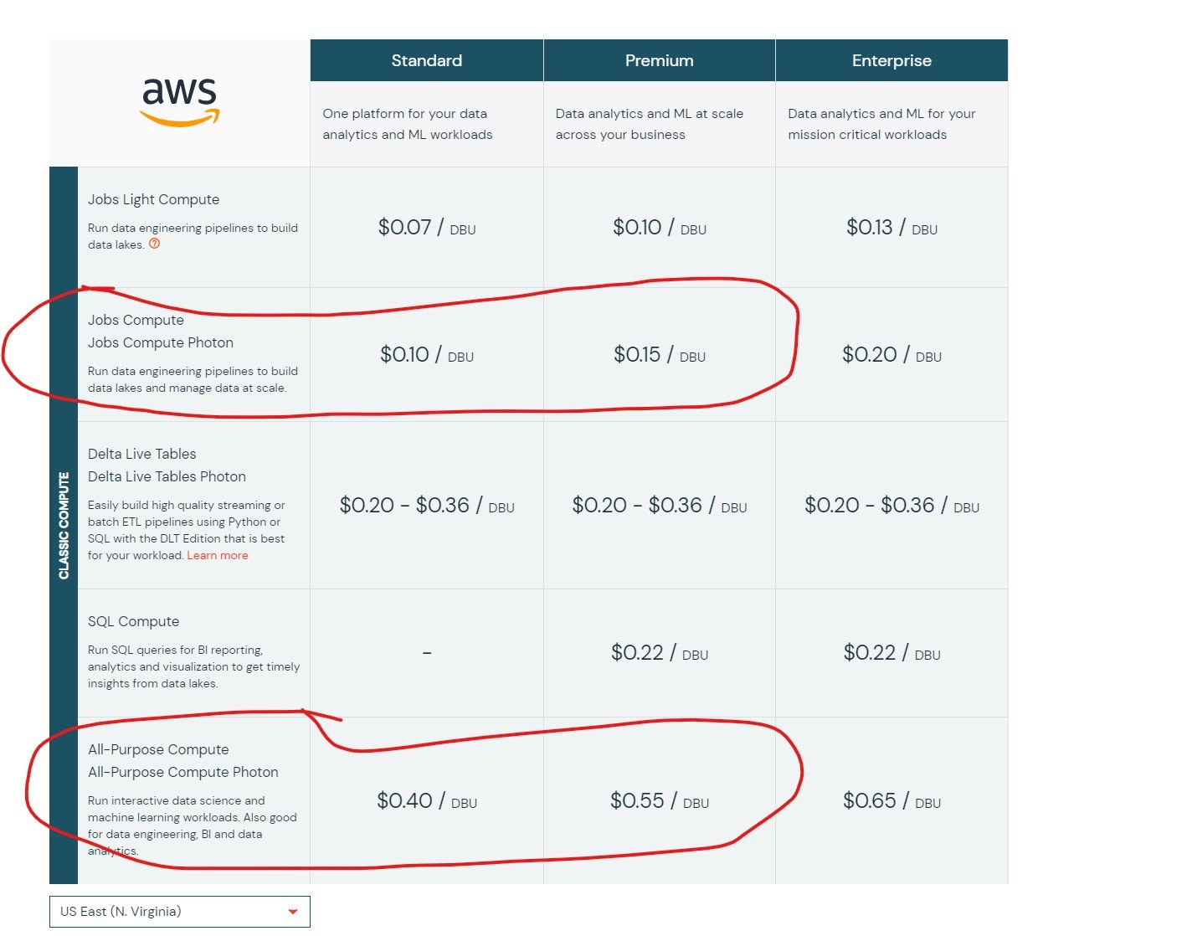

Domain
Production Pipelines
Question 15Skipped
Your team has hundreds of jobs running but it is difficult to track cost of each job run, you are asked to provide a recommendation on how to monitor and track cost across various workloads
Create jobs in different workspaces, so we can track the cost easily
Correct answer
Use Tags, during job creation so cost can be easily tracked
Use job logs to monitor and track the costs
Use workspace admin reporting
Use a single cluster for all the jobs, so cost can be easily tracked
Overall explanation
The answer is Use Tags, during job creation so cost can be easily tracked

Review below link for more details https://docs.databricks.com/administration-guide/account-settings/usage-detail-tags-aws.html

Here is a view how tags get propagated from pools to clusters and clusters without pools,

Domain
Production Pipelines
Question 16Skipped
The sales team has asked the Data engineering team to develop a dashboard that shows sales performance for all stores, but the sales team would like to use the dashboard but would like to select individual store location, which of the following approaches Data Engineering team can use to build this functionality into the dashboard.
Correct answer
Use query Parameters which then allow user to choose any location
Currently dashboards do not support parameters
Use Databricks REST API to create a dashboard for each location
Use SQL UDF function to filter the data based on the location
Use Dynamic views to filter the data based on the location
Overall explanation
The answer is

Databricks supports many types of parameters in the dashboard, a drop-down list can be created based on a query that has a unique list of store locations.

Here is a simple query that takes a parameter for

SELECT * FROM sales WHERE field IN ( {{ Multi Select Parameter }} )
Or
SELECT * FROM sales WHERE field = {{ Single Select Parameter }}

Query parameter types
- Text
- Number
- Dropdown List
- Query Based Dropdown List
- Date and Time

Domain
Production Pipelines
Question 17Skipped
You are working on a dashboard that takes a long time to load in the browser, due to the fact that each visualization contains a lot of data to populate, which of the following approaches can be taken to address this issue?
Increase size of the SQL endpoint cluster
Increase the scale of maximum range of SQL endpoint cluster
Correct answer
Use Databricks SQL Query filter to limit the amount of data in each visualization
Remove data from Delta Lake
Use Delta cache to store the intermediate results
Overall explanation
Note*: The question may sound misleading but these are types of questions the exam tries to ask.

A query filter lets you interactively reduce the amount of data shown in a visualization, similar to query parameter but with a few key differences. A query filter limits data after it has been loaded into your browser. This makes filters ideal for smaller datasets and environments where query executions are time-consuming, rate-limited, or costly.
This query filter is different from than filter that needs to be applied at the data level, this filter is at the visualization level so you can toggle how much data you want to see.

- SELECT action AS `action::filter`, COUNT(0) AS "actions count"
- FROM events
- GROUP BY action

When queries have filters you can also apply filters at the dashboard level. Select the Use Dashboard Level Filters checkbox to apply the filter to all queries.

Dashboard filters

Query filters | Databricks on AWS

Domain
Production Pipelines
Question 18Skipped
One of the queries in the Databricks SQL Dashboard takes a long time to refresh, which of the below steps can be taken to identify the root cause of this issue?
Restart the SQL endpoint
Select the SQL endpoint cluster, spark UI, SQL tab to see the execution plan and time spent in each step
Run optimize and Z ordering
Change the Spot Instance Policy from “Cost optimized” to “Reliability Optimized.”
Correct answer
Use Query History, to view queries and select query, and check query profile to time spent in each step
Overall explanation
The answer is, Use Query History, to view queries and select query, and check the query profile to see time spent in each step.

Here is the view of the query profile, for more info use the link
https://docs.microsoft.com/en-us/azure/databricks/sql/admin/query-profile

As you can see here Databricks SQL query profile is much different to Spark UI and provides much more clear information on how time is being spent on different queries and time it spent on each step.

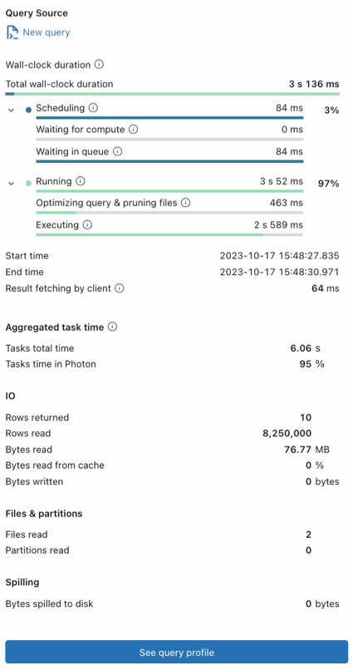

Domain
Production Pipelines
Question 19Skipped
A SQL Dashboard was built for the supply chain team to monitor the inventory and product orders, but all of the timestamps displayed on the dashboards are showing in UTC format, so they requested to change the time zone to the location of New York. How would you approach resolving this issue?
Move the workspace from Central US zone to East US Zone
Change the timestamp on the delta tables to America/New_York format
Change the spark configuration of SQL endpoint to format the timestamp to America/New_York
Correct answer
Under SQL Admin Console, set the SQL configuration parameter time zone to America/New_York
Add SET Timezone = America/New_York on every of the SQL queries in the dashboard.
Overall explanation
The answer is, Under SQL Admin Console, set the SQL configuration parameter time zone to America/New_York

Here are steps you can take this to configure, so the entire dashboard is changed without changing individual queries

Configure SQL parameters
To configure all warehouses with SQL parameters:
- Click
Settings at the bottom of the sidebar and select SQL Admin Console.
- Click the SQL Warehouse Settings tab.
- In the SQL Configuration Parameters textbox, specify one key-value pair per line. Separate the name of the parameter from its value using a space. For example, to enable ANSI_MODE:
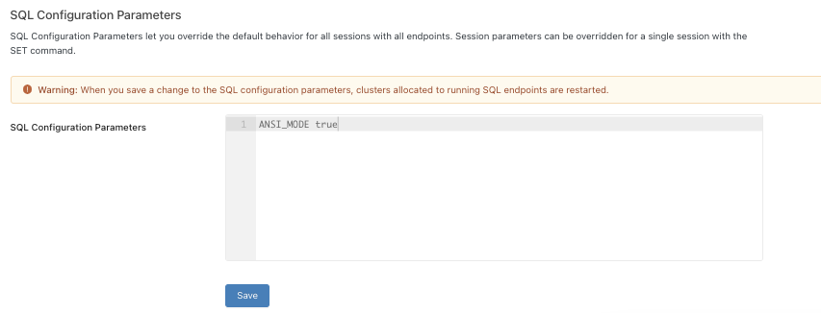
Similarly, we can add a line in the SQL Configuration parameters
timezone America/New_York
SQL configuration parameters | Databricks on AWS
Domain
Production Pipelines
Question 20Skipped
Which of the following technique can be used to implement fine-grained access control to rows and columns of the Delta table based on the user's access?
Use Unity catalog to grant access to rows and columns
Row and column access control lists
Correct answer
Use dynamic view functions
Data access control lists
Dynamic Access control lists with Unity Catalog
Overall explanation
The answer is, Use dynamic view functions.

Here is an example that limits access to rows based on the user being part managers group, in the below view if a user is not a part of the manager's group you can only see rows where the total amount is <= 1000000

Dynamic view function to filter rows

- CREATE VIEW sales_redacted AS
- SELECT user_id, country, product, total
- FROM sales_raw
- WHERE CASE WHEN is_member('managers') THEN TRUE ELSE total <= 1000000 END;

Dynamic view function to hide a column data based on user's access,

- CREATE VIEW sales_redacted AS
- SELECT user_id,
- CASE WHEN is_member('auditors') THEN email ELSE 'REDACTED' END AS email,
- country,
- product,
- total
- FROM sales_raw

Please review below for more details
https://docs.microsoft.com/en-us/azure/databricks/security/access-control/table-acls/object-privileges#dynamic-view-functions
Domain
Data Governance
Question 21Skipped
Unity catalog helps you manage the below resources in Databricks at account level
Tables
ML Models
Dashboards
Meta Stores and Catalogs
Correct answer
All of the above
Overall explanation
The answer is all of the above.
Unity Catalog is a unified governance solution for all data and AI assets including files, tables, machine learning models, and dashboards in your lakehouse on any cloud.

Domain
Data Governance
Question 22Skipped
John Smith is a newly joined team member in the Marketing team who currently has access read access to sales tables but does not have access to delete rows from the table, which of the following commands help you accomplish this?
GRANT USAGE ON TABLE table_name TO john.smith@marketing.com
GRANT DELETE ON TABLE table_name TO john.smith@marketing.com
GRANT DELETE TO TABLE table_name ON john.smith@marketing.com
GRANT MODIFY TO TABLE table_name ON john.smith@marketing.com
Correct answer
GRANT MODIFY ON TABLE table_name TO john.smith@marketing.com
Overall explanation
The answer is GRANT MODIFY ON TABLE table_name TO john.smith@marketing.com , please note INSERT, UPDATE, and DELETE are combined into one role called MODIFY.

Below are the list of privileges that can be granted to a user or a group,

SELECT: gives read access to an object.
CREATE: gives the ability to create an object (for example, a table in a schema).
MODIFY: gives the ability to add, delete, and modify data to or from an object.
USAGE: does not give any abilities, but is an additional requirement to perform any action on a schema object.
READ_METADATA: gives the ability to view an object and its metadata.
CREATE_NAMED_FUNCTION: gives the ability to create a named UDF in an existing catalog or schema.
MODIFY_CLASSPATH: gives the ability to add files to the Spark classpath.
ALL PRIVILEGES: gives all privileges (is translated into all the above privileges

Domain
Data Governance
Question 23Skipped
Kevin is the owner of both the sales table and regional_sales_vw view which uses the sales table as the underlying source for the data, and Kevin is looking to grant select privilege on the view regional_sales_vw to one of newly joined team members Steven. Which of the following is a true statement?
Kevin can not grant access to Steven since he does not have security admin privilege
Kevin although is the owner but does not have ALL PRIVILEGES permission
Correct answer
Kevin can grant access to the view, because he is the owner of the view and the underlying table
Kevin can not grant access to Steven since he does have workspace admin privilege
Steve will also require SELECT access on the underlying table
Overall explanation
The answer is, Kevin can grant access to the view, because he is the owner of the view and the underlying table,
Ownership determines whether or not you can grant privileges on derived objects to other users, a user who creates a schema, table, view, or function becomes its owner. The owner is granted all privileges and can grant privileges to other users
Domain
Data Governance
Question 24Skipped
Identify one of the below statements that can query a delta table in PySpark Dataframe API
Spark.read.mode("delta").table("table_name")
Spark.read.table.delta("table_name")
Correct answer
Spark.read.table("table_name")
Spark.read.format("delta").LoadTableAs("table_name")
Spark.read.format("delta").TableAs("table_name")
Domain
ELT with Spark SQL and Python
Question 25Skipped
You are currently working on storing data you received from different customer surveys, this data is highly unstructured and changes over time, why Lakehouse is a better choice compared to a Data warehouse?
Correct answer
Lakehouse supports schema enforcement and evolution, traditional data warehouses lack schema evolution.
Lakehouse supports SQL
Lakehouse supports ACID
Lakehouse enforces data integrity
Lakehouse supports primary and foreign keys like a data warehouse
Domain
Databricks Lakehouse Platform
Question 26Skipped
Which of the following locations hosts the driver and worker nodes of a Databricks-managed cluster?
Correct answer
Data plane
Control plane
Databricks Filesystem
JDBC data source
Databricks web application
Overall explanation
The answer is Data Plane, which is where compute(all-purpose, Job Cluster, DLT) are stored this is generally a customer cloud account, there is one exception SQL Warehouses, currently there are 3 types of SQL Warehouse compute available(classic, pro, serverless), in classic and pro compute is located in customer cloud account but serverless computed is located in Databricks cloud account.
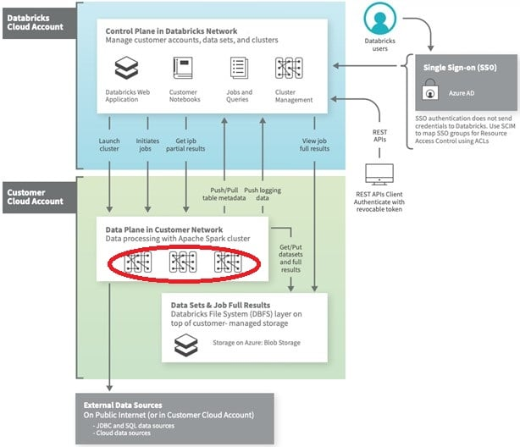
Domain
Databricks Lakehouse Platform
Question 27Skipped
You have written a notebook to generate a summary data set for reporting, Notebook was scheduled using the job cluster, but you realized it takes an average of 8 minutes to start the cluster, what feature can be used to start the cluster in a timely fashion?
Setup an additional job to run ahead of the actual job so the cluster is running second job starts
Correct answer
Use the Databricks cluster pools feature to reduce the startup time
Use Databricks Premium edition instead of Databricks standard edition
Pin the cluster in the cluster UI page so it is always available to the jobs
Disable auto termination so the cluster is always running
Overall explanation
Cluster pools allow us to reserve VM's ahead of time, when a new job cluster is created VM are grabbed from the pool. Note: when the VM's are waiting to be used by the cluster only cost incurred is Azure. Databricks run time cost is only billed once VM is allocated to a cluster.
Here is a demo of how to setup and follow some best practices,
https://www.youtube.com/watch?v=FVtITxOabxg&ab_channel=DatabricksAcademy
Domain
Databricks Lakehouse Platform
Question 28Skipped
Which of the following statement is true about Databricks repos?
You can approve the pull request if you are the owner of Databricks repos
A workspace can only have one instance of git integration
Databricks Repos and Notebook versioning are the same features
You cannot create a new branch in Databricks repos
Correct answer
Databricks repos allow you to comment and commit code changes and push them to a remote branch
Overall explanation
See below diagram to understand the role Databricks Repos and Git provider plays when building a CI/CD workdlow.
All the steps highlighted in yellow can be done Databricks Repo, all the steps highlighted in Gray are done in a git provider like Github or Azure Devops

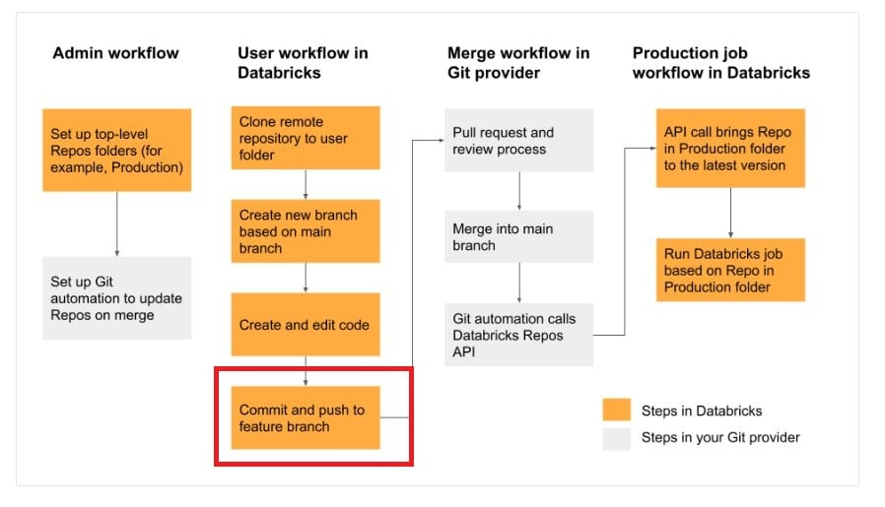
Domain
Databricks Lakehouse Platform
Question 29Skipped
Which of the statement is correct about the cluster pools?
Cluster pools allow you to perform load balancing
Cluster pools allow you to create a cluster
Correct answer
Cluster pools allow you to save time when starting a new cluster
Cluster pools are used to share resources among multiple teams
Cluster pools allow you to have all the nodes in the cluster from single physical server rack
Domain
Databricks Lakehouse Platform
Question 30Skipped
Once a cluster is deleted, below additional actions need to performed by the administrator
Remove virtual machines but storage and networking are automatically dropped
Drop storage disks but Virtual machines and networking are automatically dropped
Remove networking but Virtual machines and storage disks are automatically dropped
Remove logs
Correct answer
No action needs to be performed. All resources are automatically removed.
Domain
Databricks Lakehouse Platform
Question 31Skipped
How does a Delta Lake differ from a traditional data lake?
Delta lake is Datawarehouse service on top of data lake that can provide reliability, security, and performance
Delta lake is a caching layer on top of data lake that can provide reliability, security, and performance
Correct answer
Delta lake is an open storage format like parquet with additional capabilities that can provide reliability, security, and performance
Delta lake is an open storage format designed to replace flat files with additional capabilities that can provide reliability, security, and performance
Delta lake is proprietary software designed by Databricks that can provide reliability, security, and performance
Overall explanation
What is Delta?

Delta lake is
· Open source
· Builds up on standard data format
· Optimized for cloud object storage
· Built for scalable metadata handling
Delta lake is not
· Proprietary technology
· Storage format
· Storage medium
· Database service or data warehouse
Domain
Databricks Lakehouse Platform
Question 32Skipped
How VACCUM and OPTIMIZE commands can be used to manage the DELTA lake?
VACCUM command can be used to compact small parquet files, and the OPTIMZE command can be used to delete parquet files that are marked for deletion/unused.
VACCUM command can be used to delete empty/blank parquet files in a delta table. OPTIMIZE command can be used to update stale statistics on a delta table.
VACCUM command can be used to compress the parquet files to reduce the size of the table, OPTIMIZE command can be used to cache frequently delta tables for better performance.
VACCUM command can be used to delete empty/blank parquet files in a delta table, OPTIMIZE command can be used to cache frequently delta tables for better performance.
Correct answer
OPTIMIZE command can be used to compact small parquet files, and the VACCUM command can be used to delete parquet files that are marked for deletion/unused.
Overall explanation
VACCUM:
You can remove files no longer referenced by a Delta table and are older than the retention threshold by running the vacuum command on the table. vacuum is not triggered automatically. The default retention threshold for the files is 7 days. To change this behavior, see Configure data retention for time travel.

OPTIMIZE:
Using OPTIMIZE you can compact data files on Delta Lake, this can improve the speed of read queries on the table. Too many small files can significantly degrade the performance of the query.
Domain
Databricks Lakehouse Platform
Question 33Skipped
Which of the below commands can be used to drop a DELTA table?
DROP DELTA table_name
Correct answer
DROP TABLE table_name
DROP TABLE table_name FORMAT DELTA
DROP table_name
Domain
Databricks Lakehouse Platform
Question 34Skipped
Delete records from the transactions Delta table where transactionDate is greater than current timestamp?
DELETE FROM transactions FORMAT DELTA where transactionDate > currenct_timestmap()
DELETE FROM transactions if transctionDate > current_timestamp()
Correct answer
DELETE FROM transactions where transactionDate > current_timestamp()
DELETE FROM transactions where transactionDate > current_timestamp() KEEP_HISTORY
DELET FROM transactions where transactionDate GE current_timestamp()
Domain
Databricks Lakehouse Platform
Question 35Skipped
How does Lakehouse replace the dependency on using Data lakes and Data warehouses in a Data and Analytics solution?
Open, direct access to data stored in standard data formats.
Supports ACID transactions.
Supports BI and Machine learning workloads
Support for end-to-end streaming and batch workloads
Correct answer
All the above
Overall explanation
Lakehouse combines the benefits of a data warehouse and data lakes,

Lakehouse = Data Lake + DataWarehouse

Here are some of the major benefits of a lakehouse

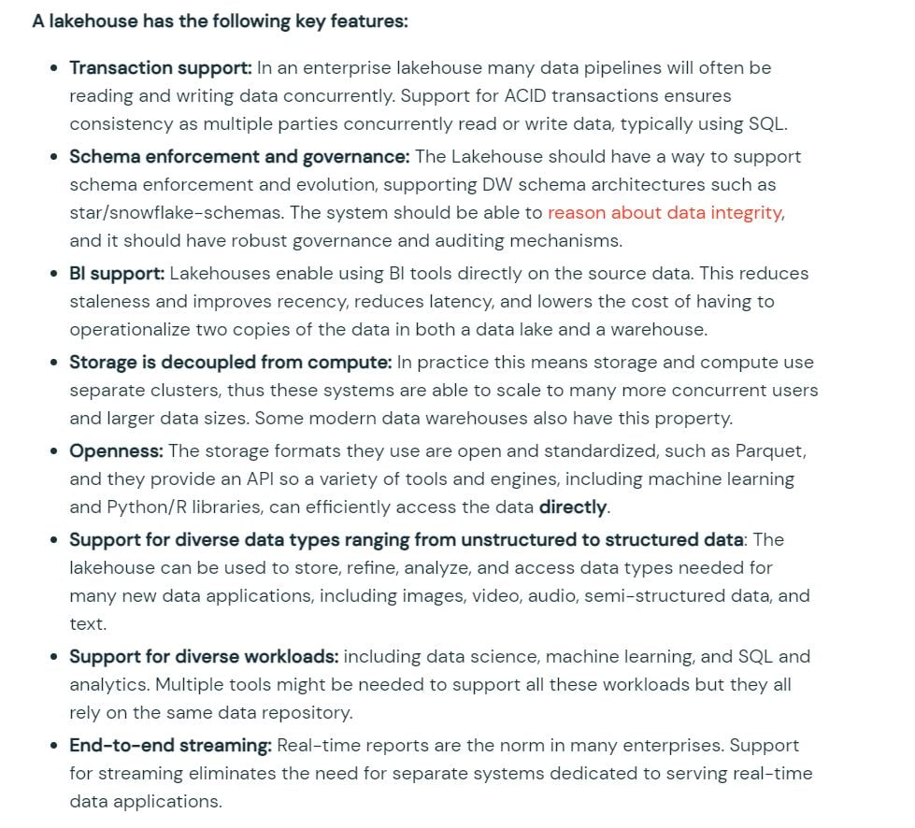

Lakehouse = Data Lake + DataWarehouse
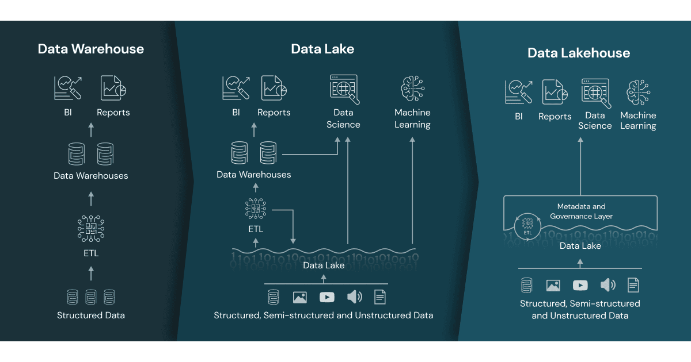

Domain
Databricks Lakehouse Platform
Question 36Skipped
The default threshold of VACUUM is 7 days, internal audit team asked to certain tables to maintain at least 365 days as part of compliance requirement, which of the below setting is needed to implement.

Correct answer
ALTER TABLE table_name set TBLPROPERTIES (delta.deletedFileRetentionDuration= ‘interval 365 days’)
MODIFY TABLE table_name set TBLPROPERTY (delta.maxRetentionDays = ‘interval 365 days’)
ALTER TABLE table_name set EXENDED TBLPROPERTIES (delta.deletedFileRetentionDuration= ‘interval 365 days’)
ALTER TABLE table_name set EXENDED TBLPROPERTIES (delta.vaccum.duration= ‘interval 365 days’)
Overall explanation
- ALTER TABLE table_name SET TBLPROPERTIES ( property_key [ = ] property_val [, ...] )

TBLPROPERTIES allow you to set key-value pairs

Table properties and table options (Databricks SQL) | Databricks on AWS
Domain
ELT with Spark SQL and Python
Question 37Skipped
Which of the following commands can be used to query a delta table?
- %python
- spark.sql("select * from table_name")
- %sql
- Select * from table_name
Correct answer
Both A & B
- %python
- execute.sql("select * from table")
- %python
- delta.sql("select * from table")
Overall explanation
The answer is both options A and B
Options C and D are incorrect because there is no command in Spark called execute.sql or delta.sql
Domain
ELT with Spark SQL and Python
Question 38Skipped
Below table temp_data has one column called raw contains JSON data that records temperature for every four hours in the day for the city of Chicago, you are asked to calculate the maximum temperature that was ever recorded for 12:00 PM hour across all the days. Parse the JSON data and use the necessary array function to calculate the max temp.

Table: temp_date
Column: raw
Datatype: string

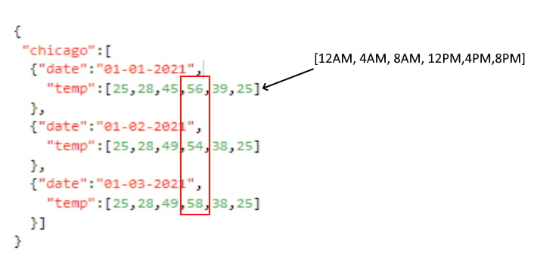
Expected output: 58

- select max(raw.chicago.temp[3]) from temp_data
- select array_max(raw.chicago[*].temp[3]) from temp_data
- select array_max(from_json(raw['chicago'].temp[3],'array<int>')) from temp_data
Correct answer
- select array_max(from_json(raw:chicago[*].temp[3],'array<int>')) from temp_data
- select max(from_json(raw:chicago[3].temp[3],'array<int>')) from temp_data
Overall explanation
Note: This is a difficult question, more likely you may see easier questions similar to this but the more you are prepared for the exam easier it is to pass the exam.

Use this below link to look for more examples, this will definitely help you,
https://docs.databricks.com/optimizations/semi-structured.html

Here is the solution, step by step

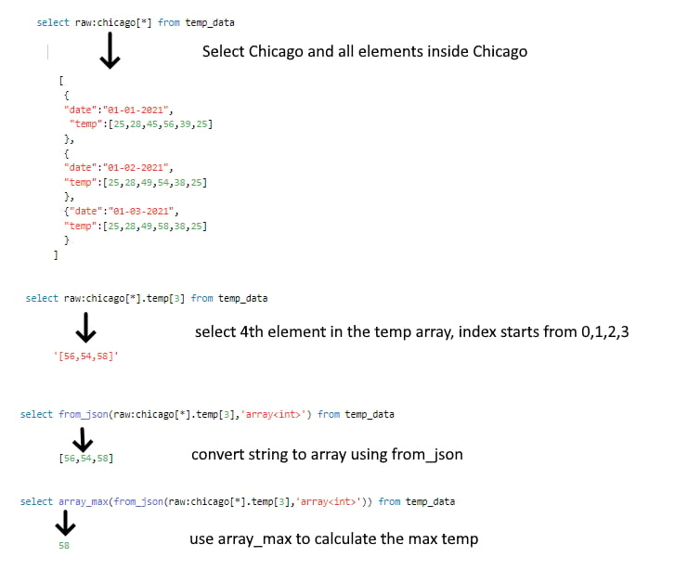

Use this below link to look for more examples, this will definitely help you,

https://docs.databricks.com/optimizations/semi-structured.html

If you want to try this solution use below DDL,

- create or replace table temp_data
- as select ' {
- "chicago":[
- {"date":"01-01-2021",
- "temp":[25,28,45,56,39,25]
- },
- {"date":"01-02-2021",
- "temp":[25,28,49,54,38,25]
- },
- {"date":"01-03-2021",
- "temp":[25,28,49,58,38,25]
- }]
- }
- ' as raw

- select array_max(from_json(raw:chicago[*].temp[3],'array<int>')) from temp_data

Domain
ELT with Spark SQL and Python
Question 39Skipped
Which of the following SQL statements can be used to update a transactions table, to set a flag on the table from Y to N
MODIFY transactions SET active_flag = 'N' WHERE active_flag = 'Y'
MERGE transactions SET active_flag = 'N' WHERE active_flag = 'Y'
Correct answer
UPDATE transactions SET active_flag = 'N' WHERE active_flag = 'Y'
REPLACE transactions SET active_flag = 'N' WHERE active_flag = 'Y'
Overall explanation
The answer is
UPDATE transactions SET active_flag = 'N' WHERE active_flag = 'Y'

Delta Lake supports UPDATE statements on the delta table, all of the changes as part of the update are ACID compliant.

Domain
ELT with Spark SQL and Python
Question 40Skipped
Below sample input data contains two columns, one cartId also known as session id, and the second column is called items, every time a customer makes a change to the cart this is stored as an array in the table, the Marketing team asked you to create a unique list of item’s that were ever added to the cart by each customer, fill in blanks by choosing the appropriate array function so the query produces below expected result as shown below.

Schema: cartId INT, items Array<INT>

Sample Data

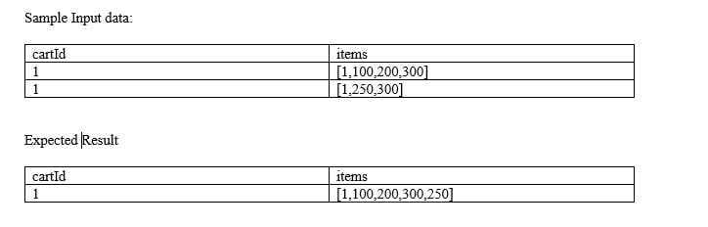

- SELECT cartId, ___ (___(items)) as items
- FROM carts GROUP BY cartId

Expected result:
cartId items
1 [1,100,200,300,250]

FLATTEN, COLLECT_UNION
ARRAY_UNION, FLATTEN
ARRAY_UNION, ARRAY_DISTINT
Correct answer
ARRAY_UNION, COLLECT_SET
ARRAY_DISTINCT, ARRAY_UNION
Overall explanation
COLLECT SET is a kind of aggregate function that combines a column value from all rows into a unique list

ARRAY_UNION combines and removes any duplicates,

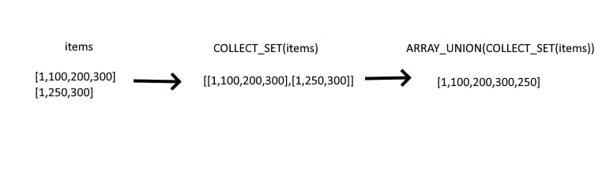
Domain
ELT with Spark SQL and Python
Question 41Skipped
You were asked to identify number of times a temperature sensor exceed threshold temperature (100.00) by each device, each row contains 5 readings collected every 5 minutes, fill in the blank with the appropriate functions.

Schema: deviceId INT, deviceTemp ARRAY<double>, dateTimeCollected TIMESTAMP

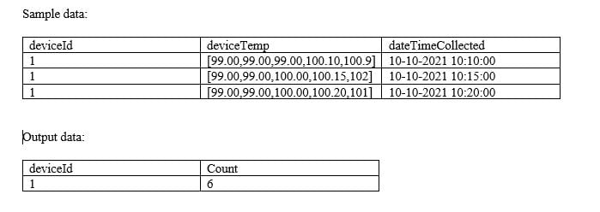

SELECT deviceId, __ (__ (__(deviceTemp], i -> i > 100.00)))
FROM devices
GROUP BY deviceId

SUM, COUNT, SIZE
SUM, SIZE, SLICE
SUM, SIZE, ARRAY_CONTAINS
SUM, SIZE, ARRAY_FILTER
Correct answer
SUM, SIZE, FILTER
Overall explanation
FILER function can be used to filter an array based on an expression
SIZE function can be used to get size of an array
SUM is used to calculate to total by device

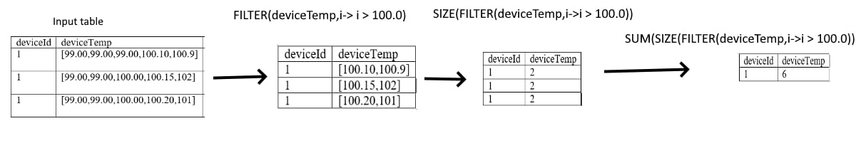
Domain
ELT with Spark SQL and Python
Question 42Skipped
You are currently looking at a table that contains data from an e-commerce platform, each row contains a list of items(Item number) that were present in the cart, when the customer makes a change to the cart the entire information is saved as a separate list and appended to an existing list for the duration of the customer session, to identify all the items customer bought you have to make a unique list of items, you were asked to create a unique item’s list that was added to the cart by the user, fill in the blanks of below query by choosing the appropriate higher-order function?
Note: See below sample data and expected output.

Schema: cartId INT, items Array<INT>

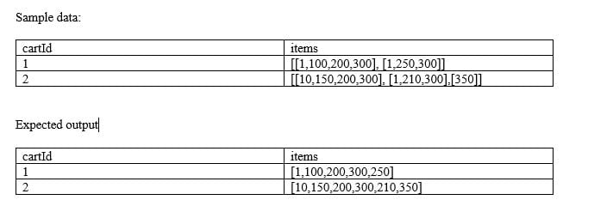

Fill in the blanks:

SELECT cartId, _(_(items)) FROM carts

ARRAY_UNION, ARRAY_DISCINT
ARRAY_DISTINCT, ARRAY_UNION
Correct answer
ARRAY_DISTINCT, FLATTEN
FLATTEN, ARRAY_DISTINCT
ARRAY_DISTINCT, ARRAY_FLATTEN
Overall explanation
FLATTEN -> Transforms an array of arrays into a single array.
ARRAY_DISTINCT -> The function returns an array of the same type as the input argument where all duplicate values have been removed.

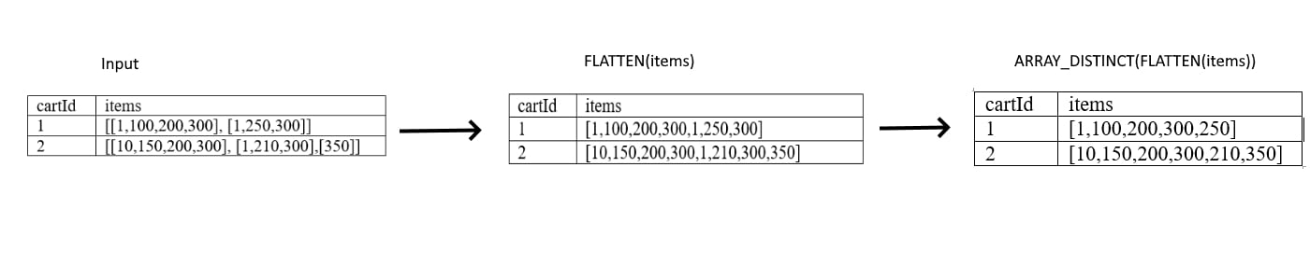
Domain
ELT with Spark SQL and Python
Question 43Skipped
You are working on IOT data where each device has 5 reading in an array collected in Celsius, you were asked to covert each individual reading from Celsius to Fahrenheit, fill in the blank with an appropriate function that can be used in this scenario.

Schema: deviceId INT, deviceTemp ARRAY<double>

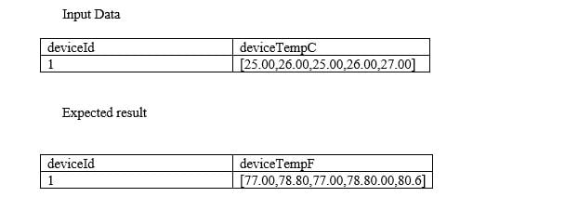

SELECT deviceId, __(deviceTempC,i-> (i * 9/5) + 32) as deviceTempF
FROM sensors
APPLY
MULTIPLY
ARRAYEXPR
Correct answer
TRANSFORM
FORALL
Overall explanation
TRANSFORM -> Transforms elements in an array in expr using the function func.

- transform(expr, func)
Domain
ELT with Spark SQL and Python
Question 44Skipped
Which of the following array functions takes input column return unique list of values in an array?
COLLECT_LIST
Correct answer
COLLECT_SET
COLLECT_UNION
ARRAY_INTERSECT
ARRAY_UNION
Overall explanation
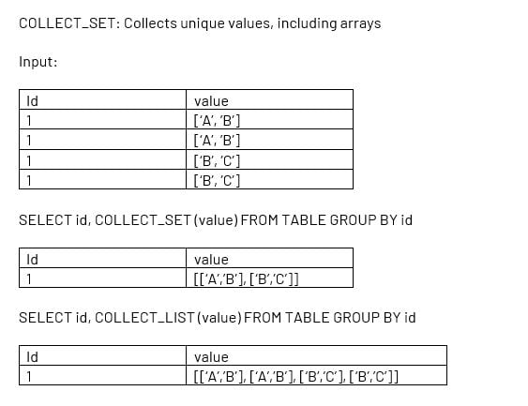

Domain
ELT with Spark SQL and Python
Question 45Skipped
You are looking to process the data based on two variables, one to check if the department is supply chain or check if process flag is set to True
if department = “supply chain” | process:
if department == “supply chain” or process = TRUE:
if department == “supply chain” | process == TRUE:
if department == “supply chain” | if process == TRUE:
Correct answer
if department == “supply chain” or process:
Domain
ELT with Spark SQL and Python

